Bahria University,

Karachi Campus



LAB EXPERIMENT NO.

**13**

LIST OF TASKS

|  |  |
| --- | --- |
| TASK NO | OBJECTIVE |
| 1 | **Implement a menu in your Android application with three menu items: "Home", "Settings", and "About". Display the menu in the options menu of your activity. Handle the selection of each menu item by displaying a Toast message indicating which item was selected.** |
| 2 | **Enhance the menu in your Android application by adding icons to the menu items. Choose appropriate icons from the material design icon library or create custom icons. Display the icons alongside the menu item text in the options menu. Update the onOptionsItemSelected method to handle the selection of each menu item and display a Toast message with the item's name and icon.** |
| 3 | **Extend your existing menu by adding a submenu with two grouped items: "Share" and "Rate App". The submenu should appear when the user selects the "Options" menu item. Implement functionality to handle the selection of each submenu item. For example, when the user selects "Share," display a dialog box allowing them to share the app's link via various sharing options.** |

**Task 1: Implement a menu in your Android application with three menu items: "Home", "Settings", and "About". Display the menu in the options menu of your activity. Handle the selection of each menu item by displaying a Toast message indicating which item was selected.**

**Solution:**

**Design:**

**Main Design:**

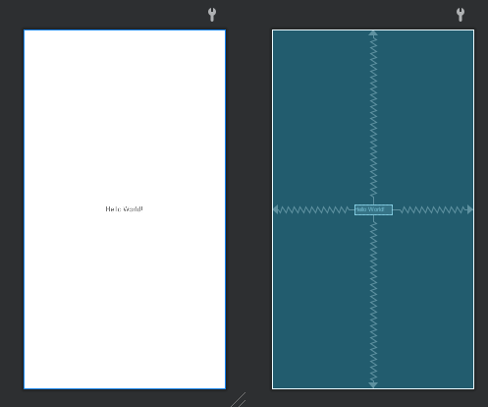

**Menu Design:**

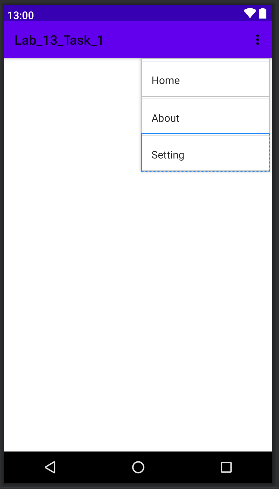

**Code:**

**MainActivity Class:**

public class MainActivity extends AppCompatActivity {

private TextView textView;

@SuppressLint("MissingInflatedId")

@Override

protected void onCreate(Bundle savedInstanceState) {

super.onCreate(savedInstanceState);

setContentView(R.layout.activity_main);

textView = findViewById(R.id.textView);

}

@Override

public boolean onCreateOptionsMenu(Menu menu) {

getMenuInflater().inflate(R.menu.main_menu, menu);

return true;

}

@Override

public boolean onOptionsItemSelected(MenuItem item) {

switch (item.getItemId()) {

case R.id.menu_item1:

showToast("Home");

return true;

case R.id.menu_item2:

showToast("About");

return true;

case R.id.menu_item3:

showToast("Setting");

return true;

default:

return super.onOptionsItemSelected(item);

}

}

private void showToast(String message) {

Toast.makeText(this, message, Toast.LENGTH_SHORT).show();

}

}

**Output:**

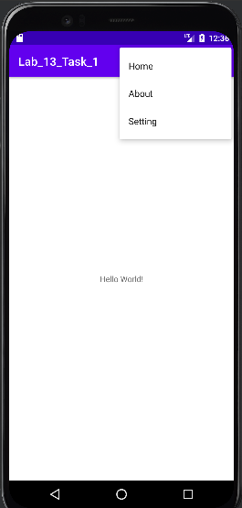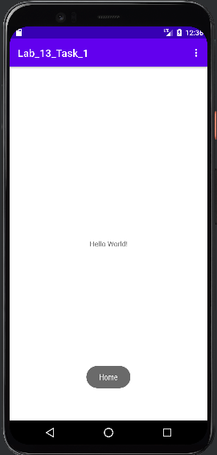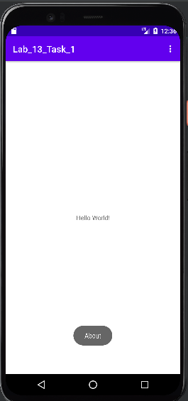

**Task 2: Enhance the menu in your Android application by adding icons to the menu items. Choose appropriate icons from the material design icon library or create custom icons. Display the icons alongside the menu item text in the options menu. Update the onOptionsItemSelected method to handle the selection of each menu item and display a Toast message with the item's name and icon.**

**Design:**

**Menu:**

**Code:**

**MainActivity Class:**

public class MainActivity extends AppCompatActivity {

private TextView textView;

@SuppressLint("MissingInflatedId")

@Override

protected void onCreate(Bundle savedInstanceState) {

super.onCreate(savedInstanceState);

setContentView(R.layout.activity_main);

textView = findViewById(R.id.textView);

}

@Override

public boolean onCreateOptionsMenu(Menu menu) {

getMenuInflater().inflate(R.menu.main_menu, menu);

// Programmatically set icons for menu items

MenuItem homeItem = menu.findItem(R.id.menu_item1);

homeItem.setIcon(R.drawable.ic_home);

MenuItem settingsItem = menu.findItem(R.id.menu_item2);

settingsItem.setIcon(R.drawable.ic_settings);

MenuItem aboutItem = menu.findItem(R.id.menu_item3);

aboutItem.setIcon(R.drawable.ic_info);

return true;

}

@Override

public boolean onOptionsItemSelected(MenuItem item) {

switch (item.getItemId()) {

case R.id.menu_item1:

showToast("Home \uD83C\uDFE0");

return true;

case R.id.menu_item2:

showToast("About ℹ️");

return true;

case R.id.menu_item3:

showToast("Setting ⚙️");

return true;

default:

return super.onOptionsItemSelected(item);

}

}

private void showToast(String message) {

Toast.makeText(this, message, Toast.LENGTH_SHORT).show();

}

}

**Output:**

**Task 3: Extend your existing menu by adding a submenu with two grouped items: "Share" and "Rate App". The submenu should appear when the user selects the "Options" menu item. Implement functionality to handle the selection of each submenu item. For example, when the user selects "Share," display a dialog box allowing them to share the app's link via various sharing options.**

**Design Menu:**

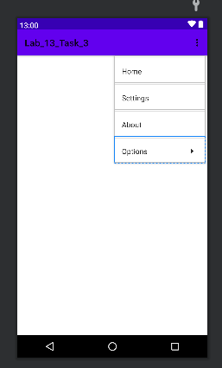

**Code:**

**MainActivity Class:**

public class MainActivity extends AppCompatActivity {

@Override

protected void onCreate(Bundle savedInstanceState) {

super.onCreate(savedInstanceState);

setContentView(R.layout.activity_main);

}

@Override

public boolean onCreateOptionsMenu(Menu menu) {

getMenuInflater().inflate(R.menu.main_menu, menu);

return true;

}

@Override

public boolean onOptionsItemSelected(@NonNull MenuItem item) {

int itemId = item.getItemId();

switch (itemId) {

case R.id.menu_item_home:

showToast("Home selected");

return true;

case R.id.menu_item_settings:

showToast("Settings selected");

return true;

case R.id.menu_item_about:

showToast("About selected");

return true;

case R.id.menu_item_share:

showShareDialog();

return true;

case R.id.menu_item_rate:

showRateAppDialog();

return true;

default:

return super.onOptionsItemSelected(item);

}

}

private void showToast(String message) {

Toast toast = Toast.makeText(this, message, Toast.LENGTH_SHORT);

toast.setGravity(Gravity.CENTER, 0, 0);

View toastView = toast.getView();

if (toastView != null && toastView instanceof LinearLayout) {

LinearLayout toastLayout = (LinearLayout) toastView;

ImageView imageView = new ImageView(this);

toastLayout.addView(imageView, 0);

}

toast.show();

}

private void showShareDialog() {

final String[] shareOptions = { "Email", "SMS", "Social Media" };

AlertDialog.Builder builder = new AlertDialog.Builder(this);

builder.setTitle("Share App")

.setItems(shareOptions, new DialogInterface.OnClickListener() {

@Override

public void onClick(DialogInterface dialog, int which) {

String selectedOption = shareOptions[which];

showToast("Shared via " + selectedOption); } })

.setNegativeButton("Cancel", new DialogInterface.OnClickListener() {

@Override

public void onClick(DialogInterface dialog, int which) {

dialog.dismiss();

} }) .create() .show(); }

private void showRateAppDialog() { AlertDialog.Builder builder = new AlertDialog.Builder(this);

builder.setTitle("Rate App") .setMessage("Enjoying the app? Please take a moment to rate it!")

.setPositiveButton("Rate Now", new DialogInterface.OnClickListener() {

@Override

public void onClick(DialogInterface dialog, int which) {

showToast("Thanks for rating!");

} }) .setNegativeButton("Later", new DialogInterface.OnClickListener() {

@Override

public void onClick(DialogInterface dialog, int which) {

dialog.dismiss();

} }) .create() .show(); }}

**Output:**

